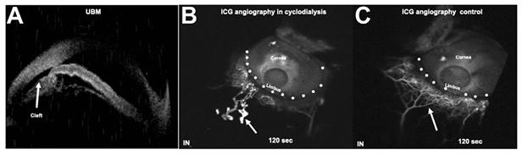

After blunt trauma, a 24-year-old man presented with an inferior cyclodialysis cleft (A) and hypotony. Indocyanine green angiographyon FLEX Spectralis revealed dilated, irregular, blind-tipped channels with variegated contrast (B, arrow), akin tolymphatics reported on angiographic imaging after trabeculectomy. This was contrary to the traditional aqueous outflow channels that are seen as acutely branching, more uniform, and narrower in width (C, arrow). Subconjunctival lymphatic trypan blue-assisted staining in the cleftregion has previously shown lymphatic over-drain after cyclodialysis . .Based on the provided images and clinical description please make an ophthalmic diagnosis for this patient. And output the diagnostic conclusions only.

**Cyclodialysis Cleft**